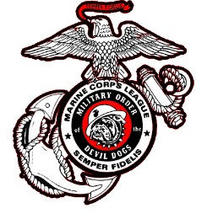

Date: 10 March 2025

To: Honorable Smart Dog PDD Charles Minton

From: PDD Helen Breen 18-305

Subject: Proposed Military Order of the Devil Dogs Constitution & Bylaws Amendment

CONSTITUTION ARTICLE II - POUNDS

***Existing Wording:***

SECTION 210: Election

1. The Annual Growl of the Pound shall be held during the three (3) months following the Supreme Growl of the Kennel.

***Proposed Wording:***

1. The Annual Growl of the Pound shall be held between 1 September and 30 November.

***Rationale:***

Each year Dogs hear “elections are to be held within 90 days after the Supreme Growl”, and “elections should be held by the Marine Corps Birthday”, but the true time frame has been fuzzy to many and left the actual time frame up to interpretation – for example, does the time frame start the day after the Supreme Growl or on September 1? By setting specific concrete dates, we give all Pounds a solid guideline as to when their Annual Growl and their Pound Elections must be held, leaving no grey area.

Respectfully Submitted,



PDD Helen Breen 18-305  
Past Pack Leader, South Carolina Pack

By Law #16

Adopted