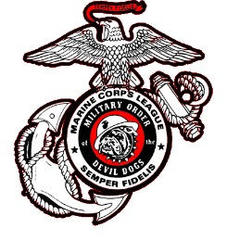

Date: 10 March 2025

To: Honorable Smart Dog PDD Charles Minton

From: PDD Helen Breen 18-305

Subject: Proposed Military Order of the Devil Dogs Constitution & Bylaws Amendment

CONSTITUTION ARTICLE III - PACKS

***Existing Wording:***

SECTION 319: Pack Default

A. A Pack shall be in default if:

1. It is indebted to the Kennel

2. It does not have a valid installation Report on file with Kennel by 30 June.

***Proposed Wording:***

A. A Pack shall be in default if:

1. It is indebted to the Kennel.

2. It does not have a valid Installation Report on file with Kennel by 31 July.

***Rationale:***

The Grand Growl of the Packs are traditionally held as part of the annual Department Conventions. Per MCL National Bylaw Section 830, Departments must hold their conventions no later than June 30th. Should a Department hold their Convention closer to the 30 June deadline, this will still give Packs a 30-day deadline to submit their Report of Installation and make it consistent with the proposed Pound deadline in Section 218.

Respectfully Submitted,



PDD Helen Breen 18-305  
Past Pack Leader, South Carolina Pack

Bylaw #19

Adopted