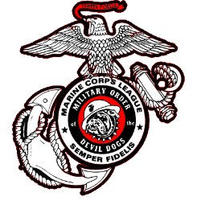

Date: 10 March 2025

To: Honorable Smart Dog PDD Charles Minton

From: PDD Helen Breen 18-305

Subject: Proposed Military Order of the Devil Dogs Constitution & Bylaws Amendment

CONSTITUTION ARTICLE III – PACKS

***Existing Wording:***

SECTION 307: Surrender / Revocation:

Paragraph B

7. Any Pack, the Charter of which has been revoked, shall surrender to the Kennel Executive Director on behalf of the Kennel Board of Trustees having jurisdictional authority over said Pack, all properties and assets. The affected properties will devolve to the control of the Kennel Board of Trustees until a new Pack is formed at which time the affected properties and assets revert to the newly formed Pack.

***Proposed Wording:***

Any Pack, the Charter of which has been revoked, shall surrender to the Kennel Dog Robber on behalf of the Kennel Board of Trustees having jurisdictional authority over said Pack, all properties and assets. The affected properties will devolve to the control of the Kennel Board of Trustees until a new Pack is formed, at which time the affected properties and assets revert to the newly formed Pack. 

***Rationale:***

After the surrendered Charter has been sent to the Executive Director, it is sent to the Kennel Dog Robber, who tracks the information on the Charter and then forwards the Charter to the Kennel Historian after the appropriate time frame for destruction.  Sending Charter to the Executive Director upon surrender at the start only adds an unnecessary step to the process.

Respectfully Submitted,



PDD Helen Breen 18-305  
Past Pack Leader, South Carolina Pack

Bylaw #21

Adopted