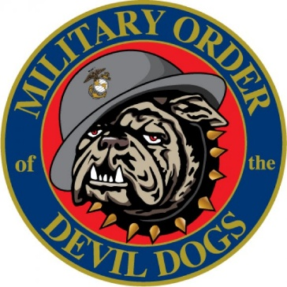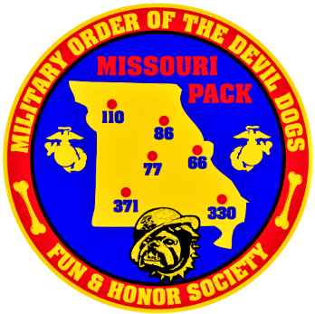
Proposed Bylaw Change
February 5, 2025

From: PDD Mark Hoernschemeyer, Worthy Sr Vice Pack Leader, Missouri Pack
To: MODD Kennel Bylaws Committee

Subj: Proposed Kennel Bylaw addition for 2025, MODD Constitution: Article IV Kennel: Section 409, C-2
Current Language:
2. The Honorable Chief Devil Dog after assuming office may appoint such other Kennel Officers and Honorable Vice Chief Devil Dogs of Divisions and Aides as he/she may see fit may also be appointed as may be fit and proper and such appointed Officers shall serve only at the convenience and pleasure of the Honorable Chief Devil Dog.

Proposed Language:
2. The Honorable Chief Devil Dog after assuming office may appoint such other Kennel Officers and Honorable Vice Chief Devil Dogs of Divisions and Aides as he/she may see fit may also be appointed as may be fit and proper and such appointed Officers shall serve only at the convenience and pleasure of the Honorable Chief Devil Dog.
3. The Honorable Vice Chief Devil Dog of the Division may be appointed provided that such appointees are not currently holding office as Worthy Pack Leaders.

Rationale: It is important to have a clear chain of command and separation of powers so if an issue arises there is no conflict of interest, leaving the only option from Pack issue to Kennel being official complaints.

Semper Woof,
PDD Mark Hoernschemeyer
Worthy Sr Vice Pack Leader
Missouri Pack
Bylaw #5
Adopted

