To: 60th Chief Devil Dog Alan Sanning
From: Kennel Mad Dog PDD Charles Minton
Subj; Mad Dog Annual report
7-29-2024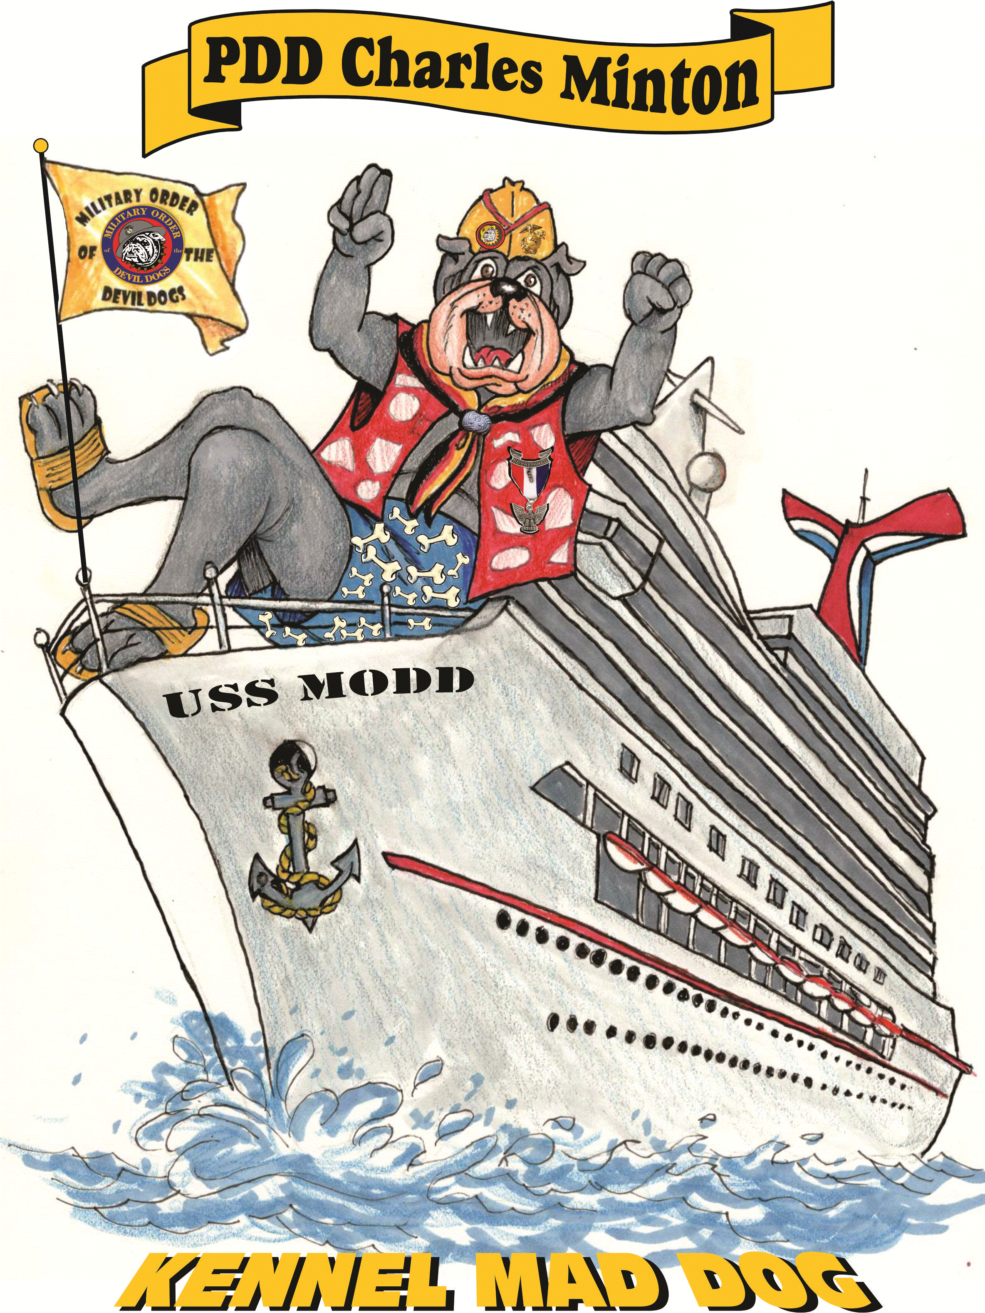
Woof Woof Honorable Chief Devil Dog,

As I sit here in my Doghouse thinking about this past year and all the amazing things that the Kennel has accomplished, I find it humbling that know that our Pounds and Packs have worked hard at raising $105,000 big bones for the Kennels Children’s Hospital fund this year, not to mention all the other charitable local organizations that the Pounds and Packs help support throughout the nation.
I get asked all the time why I enjoy being in the Military Order of the Devil Dogs so much, and for me it’s not just the fun that we have at our Growls it's more than that, it’s the all the good that we do in our communities and around the nation.
Now that operation Chow Hound is full swing it’s great to see the all the photos and hear the stories about how well this program is received by the local shelters that receive the dog food and other donations, and the instant gratification that you see on the Marines faces as they see firsthand how their contributions help when most needed.
It has been a pleasure to have served as the Honorable Mad Dog for another year, and its bittersweet for me because this will be my last year that I will have the Honor and Privilege to help initiate the newest PDD’s into the Order. In my humble opinion as, I’ve said many times before, I believe that this position is the most rewarding one in the Kennel. I have had the opportunity to work with many outstanding Dogs over the last seven years and it’s always great to see the initiates advance to PDD and see how many of the want to return as future Handlers to help the next batch of DD’s advance to the Rank of PDD. I could not have done this job without the continued support of returning Platoon Handlers and all the new assistants that volunteer each year. We continue to have fun and make the initiation process an enjoyable experience that hopefully the Dogs will remember as they continue to serve the Order.
I would also like to thank all my Deputy Mad Dogs for their support over the years, they have really stepped up and made these past years fun and memorable.
I look forward to seeing what the next chapter looks like as I run for the Honorable Smart Dog.

Semper Woofing
PDD Charles Minton
Honorable Mad Dog
Military Order of the Devil Dog
252-452-0728
ssgtcdminton@yahoo.com

