**Military Order of the Devil Dogs**

**(State) Pack**

**Bylaws**

**(Year Updated or Amended)**

**Table of Contents**

**Constitution**

Preamble ……………………………………………… C-1

Purpose ……………………………………………… C-1

Organization ……………………………………………… C-1

Membership ……………………………………………… C-2

Language ……………………………………………… C-2

Trademark/Tradename ……………………………………………… C-2

Amendments ……………………………………………… C-2

**Bylaws**

Article I- Membership ……………………………………………… B-1

Article II- Packs ……………………………………………… B-2

Article III- Fiscal and Financial …………………………………………… B-9

Article IV- Uniform ……………………………………………… B-10

Article V- Installing Officer ……………………………………………… B-11

Article VI- Discipline ……………………………………………… B-12

Article VII- Policies ……………………………………………… B-13

Article VIII- General ……………………………………………… B-14

Article IX- Amending of Bylaws ……………………………………………… B-16

Pound Bylaw Approvals ……………………………………………… B-17

**Enclosures**

Pack Dog of the Year ……………………………………………… E-1

Pack Leader’s Meritorious Commendation …………………………… E-3

Certificate of Appreciation ……………………………………………… E-3

Distinguished Service Award ……………………………………………… E-4

Pain in the Ass Award ……………………………………………… E-4

Flying Horse’s Ass Award ……………………………………………… E-4

Past Pack Leader Medal ……………………………………………… E-5

Devil Dogs Creed ……………………………………………… E-8

# Constitution

## Preamble:

We, Marines that hold an honorable discharge from the United States Marine Corps, bona fide, paid up, and active members of the Marine Corps League, Inc., do hereby unite to form a permanent organization to be known as Military Order of the Devil Dogs **(State)** Pack.

This Military Order of the Devil Dogs **(State)** Pack, Military Order of the Devil Dogs, Inc., is hereby created and organized in **(Year)** and chartered on the **(Day, Month, Year)**.

The Bylaws of Military Order of the Devil Dogs **(State)** Pack will never change or remove any Bylaws set forth in the Kennel or Pack Bylaws statute, ever forth.

## Purposes:

It shall be the purpose of this organization to:

1. Observe, obey, and support the Bylaws and Administrative Procedures of the MCL.
2. Preserve and strengthen the principles and ideals of the MCL.
3. Aid and assist in the accomplishment of all programs and objectives of the MCL.
4. As the fun and honor society of the MCL, to promote sociability, comradeship, and good fellowship, provide amusement and entertainment at all gatherings of the MCL when and where proper and advisable.
5. Maintain true allegiance to the United States of America and its Constitution and laws; to foster and extend American institutions of freedom; and to defend America against all enemies.

## Organization:

The recognized official bodies of this association shall consist of and be:

1. State organizations to be known as the **(State)** Pack of the Military Order of the Devil Dog, the meetings of which shall be known as the Pack Growl.

## Membership:

1. All new members must be voted on by the Military Order of the Devil Dogs **(State)** Pack membership at a Pound Growl according to Kennel Bylaws statute Article I, Section 101, which must be adhered to.
2. Dues for all Non-Paid Life Members in Military Order of the Devil Dogs **(State)**  Pack shall be $ **(Dues Amount)** if paid before the deadline of 31 August of each calendar year.

## Language:

Military Order of the Devil Dogs **(State)** Pack follows all Kennel Bylaws for Article V of the Constitution.

## Trademark/Tradename:

The titles “Military Order of the Devil Dog, Inc.,” “Military Order of the Devil Dogs” and “Military Order of Devil Dogs” and the official seal and logo of the MODD are the property of the MODD and are claimed as trademarks and tradenames of the MODD. Use of such titles, seal, and logos for commercial gain or profit is strictly prohibited without the prior approval in writing of the MODD.

## Amendments:

This Constitution may be amended in the following manner:

1. Devil Dogs within the Military Order of the Devil Dogs **(State)** Pack or the Pack itself, seeking amendments to this Constitution, shall submit in typewritten form to the Pack Dog Robber, no less than one hundred and twenty (120) days, who will cause the proposed amendments to be published and will provide copies of them to each member. Both acts will occur no less than ninety (90) days prior to the next Grand Growl of the Pack at which they are to be considered. The said notice of publication needs only to recite the particular provision of the Bylaw to be amended, revised, or repealed by reference.
2. The Pack Dog Robber will be guided by the instructions in Article XIII of the Kennel Bylaws to ensure that proper notifications have been made promptly.
3. Provisions One and Two of this Article have been complied with, and the proponents and opponents of each proposed amendment shall have no more than Five (5) minutes each to state their case. A "standing vote for" and a "standing vote against" shall be taken, and a correct record of the votes "for" and "against" shall be posted in the scratching of the Pack. In each case where it is found that upon a careful count that two-thirds (2/3) of the total registered Devil Dogs have voted "for" a proposed amendment, said proposed amendment shall be considered to be approved, and all members shall be supplied without delay with copies of any amendments approved by the Pack. Proposed amendments that do not receive a two-thirds (2/3) vote of approval shall be void and without effect and shall not be considered nor re-proposed until after the expiration of no less than six (6) months.
4. It shall not be permissible for any session of the Pack Growl to waive any of the foregoing provision

# Bylaws

## Article I Membership

### Section 101 Eligibility:

Military Order of the Devil Dogs **(State)** Pack follows all of the Kennel Bylaws for Article I Section 101.

### Section 102 Election:

Military Order of the Devil Dogs **(State)** Pack follows all of the Kennel Bylaws for Article I Section 103.

### Section 103 Membership Dues:

Each Pack shall fix the amount to be charged for election fees and annual membership dues. The Pack membership dues shall include the sum of the Kennel membership dues.

### Section 104 Good Standing:

Military Order of the Devil Dogs **(State)** Pack follows all of the Kennel Bylaws for Article I, Section 106.

### Section 105 Dual Membership:

1. Members who fulfill the requirements listed in Section 101 of the Kennel Bylaws. Eligibility may join more than one (1) Pound in the MODD if they so wish.
   1. The member will keep their current degree of obligation (Pedigreed Devil Dog, Devil Dog, or Pup).
   2. The member will pay separate dues to each Pound of which they hold membership.
   3. Separate life membership can be held in multiple Pounds.
   4. Since the MODD is a one (1) vote-per-dog democracy, there is no reason to declare voting rights with any one Pound.
   5. Elected or appointed Officers can be held in each Pound or Pack if there is no conflict of interest. Dogs can hold one appointed and one elected position but not concurrently hold the Office of Pack Dog Robber. As one Dog cannot cast more than one vote on the Board of Trustees, Dogs may not hold more than one elected office in the same Pound or Pack.

## Article II- Packs

### Section 201 Definition:

1. The Pack of the MODD shall correspond in character and function in the MODD as does the Department in the organization of the MCL.
2. The individual Pack shall bear the name of **(State)** Pack.
3. C. Any member of the MODD to be eligible for membership in the Pack must:
   1. Be in good standing in the MCL and in the MODD.
   2. Their membership dues in both organizations must be paid currently.
   3. They must hold the degree of Pup, Devil Dog, or Pedigreed Devil Dog.
4. The Pack shall be the official representative of the Kennel within the limits of its (Pack's) jurisdiction.

### Section 202 Bylaws:

The **(State)** Pack may adopt bylaws provided they do not conflict with or violate the Constitution and Bylaws of the Kennel, and that a copy of such Bylaws is furnished to the Honorable Smart Dog.

The Pack Smart Dog shall have the authority to make typographical, grammatical, and formatting changes to Bylaws that do not change the meaning of the Bylaws as passed by the Grand Growl of the Pack.

### Section 203 Authority of the Pack:

Military Order of the Devil Dogs **(State)** Pack follows all of the Kennel Bylaws for Article III, Section 304.

### Section 204 Growls:

Military Order of the Devil Dogs **(State)** Pack follows all of the Kennel Bylaws for Article III, Section 305.

### Section 205 Quorum:

1. **(State)** Pack must have five members in attendance to have a Quorum.
2. The quorum rule of the Pack must be part of the Pack's official scratchings and of its approved Bylaws.
3. All Pack Growls must have representation from at least two (2) Pounds.

### Section 206 Charter:

Military Order of the Devil Dogs **(State)** Pack follows all of the Kennel Bylaws for Article III Section 307.

### Section 207 Eligibility to Hold Office:

1. All members of the several Pounds comprising the membership of the Pack and holding the degree of Devil Dog or Pedigreed Devil Dog shall be eligible for election to any office of the Pack, subject to the following limitations and restrictions:
   1. The Pack Leader must have the degree of Pedigreed Devil Dog.
      1. If the Pack does not have any qualified Pedigreed Devil Dogs who are able and willing to serve as Pack Leader, then a Devil Dog who has at least two years’ service in the degree of Devil Dog may be elected as an Interim Pack Leader. An Interim Pack Leader may serve one (1) year and may not be reelected unless they have advanced to the degree of Pedigreed Devil Dog by their reelection. At the time an Interim Pack Leader with the degree of Devil Dog attains the degree of Pedigreed Devil Dog, the wording ‘Interim’ shall not apply for the remainder of their term.
      2. If a Pedigreed Devil Dog is still not available to serve as Pack Leader after the term of the Interim Pack Leader is complete, that Division Vice Chief Devil Dog will, at the direction of the Honorable Chief Devil Dog, appoint a Pedigreed Devil Dog or a Devil Dog from the Pack Staff to serve as Acting Pack Leader until the Pack has obtained a Pedigreed Devil Dog available to fill the Office.
2. To be eligible for an appointed office, a Devil Dog must have at least six (6) months of service in that Degree, and to be eligible for elected office, a Devil Dog must have at least one (1) full year of service in that Degree. This restriction may be waived only at the institution of a Pack.
3. Section 208-A-4 of the Kennel Bylaws applies.
4. Section 208-A-5 of the Kennel Bylaws applies.
5. Section 208-A-6 of the Kennel Bylaws applies.

### Section 208 Pack Officers:

1. ELECTED - The Elected Officers of **(State)** Pack shall be the Worthy Pack Leader (who shall not concurrently hold the Office of Pack Dog Robber), Worthy Senior Vice Pack Leader, Worthy Junior Vice Pack Leader, Worthy Smart Dog, Worthy Dog Trainer, Worthy Police Dog, and Worthy Mad Dog.
2. APPOINTED - The Appointed Officers of **(State)** Pack shall be the Worthy Dog Robber (who shall not concurrently hold the office of Pack Leader), the Worthy Watch Dog, and the Worthy Barking Dog, and such other subordinate Officers as the Pack Leader may choose to appoint. It is preferable that the Pack Leader-elect make the appointments following the election so as to permit the Installation of the full staff of Officers. The appointed Officers shall serve only at the convenience and pleasure of the Pack Leader.
3. STAFF—The Pack Staff shall consist of all elected Officers, the Worthy Dog Robber, the Worthy Watch Dog, the Worthy Barking Dog, and all Past Worthy Pack Leaders.
   1. **(State)** PACK BOARD OF TRUSTEES—The **(State)** Pack Board of Trustees shall consist of the elected Pack Officers and the Junior Past Pack Leader. The Worthy Dog Robber will be an ex-officio member of the Pack Board of Trustees and therefor has no vote. As one Dog cannot cast more than one vote on the Board of Trustees, Dogs may not hold more than one elected office.

### Section 209 Elections:

1. At the Grand Growl of the Pack, the annual nomination, election, appointment, and Installation of Officers shall occur for the ensuing year.
2. All nominations for elected office shall be from the floor.
3. The elected Officers may be chosen by secret ballot.
4. The ballot may be cast for the full slate of Officers or may be cast for each office in sequence.
5. Should the Pack fail to nominate for any elected office, after the election of Officers, the Pack Leader-elect shall appoint an eligible member to the office for which no nomination had been made.
6. The Worthy Police Dog will permit no person to enter or leave the Dog House while the Pack Officers are being nominated and elected.

### Section 210 Tenure:

1. All elected Pack Officers shall serve until their successor has been elected and installed or until removed from office for cause.
2. All appointed Pack Officers shall serve at the discretion of the Pack Leader but for no longer than the term of office to which the Pack Leader has been elected.
3. The Worthy Dog Robber shall be a permanent position, subject to the annual approval of the Pack Leader. The Worthy Dog Robber shall be appointed from the ranks of qualified Pedigreed Devil Dogs who are extremely knowledgeable in the administrative affairs and duties of the MODD. Should the Worthy Dog Robber decline the position for another term, they must turn over all monies and records to the newly appointed Worthy Dog Robber within thirty (30) days after the Grand Growl of the Pack.
4. The Pack Leader may only succeed themselves for one additional term.
5. All other Pack Officers may succeed themselves for as many terms of office as they are elected or appointed.

### Section 211 Past Pack Officers:

A Past Pack Officer is one who, having been elected or appointed and installed, has served to the end of their full normal term or whose term of office is terminated by death.

### Section 212 Vacancy:

1. In case of any elected or appointed office (except that of Pack Leader) shall be declared vacant during the fiscal year, the Pack Leader, with the approval of the Pack Staff, shall promptly appoint a successor for the uncompleted term of office.
2. In case the vacant office be that of Pack Leader, the Senior Vice Pack Leader shall assume all of the titles, rights, and privileges of the office of the Pack Leader for the uncompleted term thereof The Pack Staff shall immediately fill the office of the Senior Vice Pack Leader.
3. Pack offices shall be declared vacant for any of the following reasons:
   1. The Pack Officers permit themselves to become in arrears in their membership dues in the MODD and/or the MCL and/or loses their status as a member in good standing in the MODD and/or in the MCL.
   2. The Pack Officers absent themselves from two (2) consecutive Growls of the Pack and/or the Pack Staff without valid reason.
   3. For any other just cause or reason.

### Section 213 Voting:

1. Each and every member of the Pack present at the Growl and in good standing in the MCL and the MODD shall have one (1) vote.
   1. Election of candidates for membership or for office shall be by voice vote or by standing.
   2. Upon the request of five (5) or more Dogs, the vote may be by secret ballot.
   3. All other voting on Pack business shall be by voice vote.
   4. Ten (10) or more Dogs present and eligible to vote may call for a secret ballot on any matter.

### Section 214 Initiation:

1. Approved candidates for the degree of Devil Dog shall be initiated in accordance with Section 305-A of this article.
2. Subject to Section 416-B and Section 101-F-4 of the Kennel Bylaws, only a properly chartered and functioning Pack shall have the authority to confer the degree of Devil Dog.

### Section 215 Growl of the Pack:

1. The Grand Growl of the Pack will be held during the annual Department Convention of the Department Of **(State)**.
2. All other assemblies of the Pack shall be known as a Pack Growl, and any assembly of the Pack Staff shall be known as a Pack Staff Growl.
3. All Pack Growls shall be considered a formal assembly, empowered to consider motions and expend funds ONLY if the Holy Bible, Bone, and Charter (or certified copy) are present. The absence of these three (3) sacred articles shall fender the assembly an informal gathering.
4. The National Colors must be present at every Growl.

### Section 216 Order of Business:

1. The order of business of the Grand Growl of the Pack shall be:
   1. Opening Ceremony.
   2. Roll Call of Officers.
   3. Reading or Publishing of Scratchings of the previous Growl(s).
   4. Memorial Services.
   5. Old business: Officers and Committee reports: other Old Business.
   6. New Business: Resolutions, other New Business.
   7. Nomination, Election, and Installation of Officers.
   8. Good of the Order.
   9. Closing Ceremony.
2. At the discretion of the Pack Leader, a recess of the Grand Growl of the Pack may be called before the order of business "Nomination, Election, and Installation of Officers" and/or before the order of Business "Good of the Order" Nomination, election and Installation of Officers is under the direction and jurisdiction of the retiring Pack Leader and Staff.
3. Any session of a Pack Growl, or Pack Staff Growl, shall use the following order of business:
   1. Opening Ceremony.
   2. Roll Call of Officers.
   3. Recording of the Scratchings of the session.
   4. Conduct of the Business for which the session was called.
   5. Closing Ceremony.
4. The Scratchings of any session of the Pack Growl and/or Pack Staff Growl may be called up for attention and action at the next ensuing Grand Growl of the Pack under Order of Business "Reading and/or publishing of the Scratchings of the previous Growl(s)."

### Section 217 Pack Officer Duties:

1. The Pack Leader shall preside at all Growls of the Pack, Pack Staff and at all Pack initiations. It shall be the Pack Leader's duty to require the observance of and obedience to all laws, rules, and regulations not in conflict with the Constitution and Bylaws of the MODD and of the MCL. The Pack Leader may appoint other Officers and committees as deemed necessary if not otherwise provided for in these and Kennel’s Bylaws. The Pack Leader shall issue the call for all Growls of the Pack Staff as deemed necessary. The Pack Leader shall be the custodian of, with the Worthy Dog Robber, all monies, property, securities, and records of the Pack and shall countersign all orders for the disbursement of monies when approved by proper authority, perform such other duties and issue such other orders as are necessary and proper for the harmonious and efficient functioning of the MODD, the constituent units thereof, and of the membership of the MODD.
2. The Worthy Senior Vice Pack Leader shall assist the Pack Leader, preside at the Growls of the Pack and Pack Staff in the absence of the Pack Leader or at the Pack Leader's request, be responsible to the Pack Leader and the Pack for the growth and expansion of the Pack and Pounds, and perform such other duties for the good of the order as the Pack Leader may direct.
3. The Worthy Junior Vice Pack Leader shall assist the Pack Leader and the Worthy Senior Vice Pack Leader, shall be responsible for all activities seeking to increase the Pack's revenue and for supervising all entertainment and amusement provided at all Growls of the Pack and Pack Staff, and shall perform such other duties as the Pack Leader may direct.
4. The Worthy Dog Robber
   1. Shall be responsible to the Pack Leader and the Pack for all records and accounts of the Pack, shall keep a brief but proper record of all pertinent scratchings of all Pack Growls and Pack Staff Growls, and shall be the custodian with the Pack Leader, of all monies, property, securities, and records of the Pack. They shall keep on deposit in a reputable bank all monies and securities of the Pack and shall make all disbursements for all accounts owing when approved by proper authority, by check, which shall be countersigned by the Pack Leader. They shall keep an accurate and current file on all members of the **(State)** Pack. They shall perform such duties customarily executed by recording secretaries, financial secretaries, and treasurers. They shall make a full and correct accounting and report, including financial statements, to each Grand Growl of the Pack at such other times as may be directed by the Pack Leader or the Pack Staff.
5. The Worthy Smart Dog shall interpret and explain the Constitution and Bylaws of the Kennel and the **(State)** Pack and all rules and regulations established by the Pack, the Pack Staff, or the Pack Leader, when requested by a competent authority. They will update the Bylaws immediately following the Supreme Growl in which they held the office of Pack Smart Dog if any amendments were approved to the current Bylaws and forward them to the Honorable Smart Dog.
6. The Worthy Dog Trainer shall administer to the spiritual needs of the **(State)** Pack and shall prepare and conduct suitable Memorial Services at each Grand Growl of the Pack, shall inform and assist all Pound Dog Trainers in the proper performance of their duties, shall perform such other duties as the Pack Leader may direct.
7. The Worthy Police Dog shall maintain order and decorum in all Growls of the Pack and Pack Staff, shall expel from any Growl any Dog exceeding the bounds of decency, creating a disturbance, or hindering the orderly conduct of the Growl, shall perform such other duties as the Pack Leader may direct.
8. The Worthy Mad Dog shall direct and supervise the public and private initiation of candidates to the degree of Devil Dog (Pup when this degree are under the supervision of the Grand Growl of the Pack). Additional aides as may be requested and designated by the Worthy Mad Dog with the approval Pack Leader. Such initiation shall be in a manner that is entertaining and impressive with due regard to the well-being and safety of the candidate. The Initiation shall not be repulsive or against the dignity and modesty of the candidate. All other duties shall be performed in line with the office as the Pack Leader may direct.
9. The Worthy Watch Dog shall guard the portals of the Pack at all times, permitting no one to enter or leave without proper authority, and shall be responsible to the Pack Leader and the Pack for the worthiness and eligibility of every person present at any Pack or Pack Staff Growl and shall perform such other duties as the Pack Leader may direct.
10. The Worthy Barking Dog shall supervise and direct all publicity and public relations of the **(State)** Pack, under the direction of the Pack Leader, shall perform the functions commonly executed by public relations and publicity directors, shall inform and assist all Pound Barking Dogs in such manner as to insure a uniform and effective public relations program, and shall perform such other duties as the Pack Leader may direct.

## Article III Fiscal and Finance

### Section 301 Fiscal Year:

1. The fiscal year of the MODD shall be identical to the fiscal year of the MCL.
2. This runs from July 1st to June 30th.

### Section 302 Revenue:

The revenue of this Order shall be derived from the collection of membership dues, election fees, and other sources that may be approved by the Pack Growl or the Pack Staff.

* 1. Limitations: The Pack shall be limited to the spending of not over seventy-five (75%) percent of all monies received during its administration, including monies from the previous administration, and that at least twenty-five (25%) percent of such gross receipts shall be turned over to the new administration each year.
  2. Expenses of Pack Officers: The Pack Leader and Pack Dog Robber, whose attendance at the Pack and Supreme Growls is not mandatory but advisable, shall be unreimbursed. This includes but is not limited to all functions and/or transportation. The expenses to be covered will be for postage, copying, and supplies. Payment will be made upon the submission of a detailed expense report.
  3. Administrative Expense: Pack Dogs shall be reimbursed for normal administrative expenses submitted to the Worthy Dog Robber on a voucher and/or detailed expense report subject to the approval of the Pack.

### Section 303 Dues:

Military Order of the Devil Dogs **(State)** Pack follows all of the Kennel Bylaws for Article V Section 503.

### Section 304 Passports:

1. All Devil Dogs shall procure the MODD Passport at a cost regulated by the Kennel, which will distribute them to the Pounds. The fine for attending any Pack or Pound Growl will be one Big Bone ($1.00) without a Passport in any attending Devil Dogs possession.
2. The Pack and Pounds will procure a Visa Stamp to stamp all Passports with the date of all Growls attended by said Devil Dog presenting their Passport. The cost of visa stamping shall be one Big Bone ($1.00).
3. Immediately following every Growl, all Big Bones from passport stamps, passport fines and all Big Bones contributed to the Kennel Children's Hospital Donation must be forwarded to the Honorable Dog Robber.

## Article IV Uniform

### Section 401 Uniform:

1. The official uniform of the MODD shall be as follows:
   1. The MCL approved cover
   2. The appropriate MODD Dog Collar.

### Section 402 Identification Disc/Dog Collar:

Military Order of the Devil Dogs **(State)** Pack follows all of the Kennel Bylaws for Article VII, Section 703.

## Article V Installing Officers

### Section 501 Pound:

The Officer installing the new Officers of a Pound should be a Pedigreed Devil Dog if possible or shall be a Past Pound Keeper, or an incumbent elected Pound Officer, or past elected Pound Officer, or current/past Pack elected Officer, or current/past Kennel elected Officer, or a Division Vice Chief Devil Dog. Immediately following the Installation, the Installing Officer shall make a full report to the Pack Dog Robber, the Honorable Dog Robber, and the Vice Chief Devil Dog of the Division. The report shall include the date and place, names, addresses, and titles of all Officers installed.

### Section 502 Pack:

The Officer installing the new Pack Officers should be a Pedigreed Devil Dog if possible or shall be a Past Pack Leader, or an incumbent elected Pack Officer, a past elected Pack Officer, a current/past Kennel elected Officer, or a Division Vice Chief Devil Dog. Immediately following the Installation, the Installing Officer shall make a full report to the Honorable Dog Robber via the Vice Chief Devil Dog of the Division, including the date and place, names and addresses and titles of all Officers installed, and the current condition of the Pack.

## Article VI Discipline

### Section 601 Offenses:

Military Order of the Devil Dogs **(State)** Pack follows all of the Kennel Bylaws for Article X Section 1001.

### Section 602 Charges:

Military Order of the Devil Dogs **(State)** Pack follows all of the Kennel Bylaws for Article X Section 1002.

### Section 603 Procedure:

Military Order of the Devil Dogs **(State)** Pack follows all of the Kennel Bylaws for Article X Section 1003.

### Section 604 Penalties:

Military Order of the Devil Dogs **(State)** Pack follows all of the Kennel Bylaws for Article X Section 1004.

### Section 605 Record:

Military Order of the Devil Dogs **(State)** Pack follows all of the Kennel Bylaws for Article X Section 1005.

### Section 606 Officer Pending Trail:

Military Order of the Devil Dogs **(State)** Pack follows all of the Kennel Bylaws for Article X Section 1006.

## Article VII Policies

### Section 701 Commitments:

No Officer or member of the **(State)** Pack shall commit or obligate the MODD in any manner, financially or otherwise, to any outside agency, unless and until authorized to do so by proper authority, in writing.

### Section 702 MCL Politics:

No Officer or member of the **(State)** Pack shall be permitted to mention or discuss the politics or anything pertaining to the politics of the MCL in any Growl of the **(State)** Pack at any level of jurisdiction.

### Section 703 MCL Business:

No matter of MCL business shall be discussed in any Growl of the **(State)** Pack at any level of jurisdiction, unless the **(State)** Pack is officially requested to do so by the MCL.

### Section 704 Outside Political Activity:

1. Every citizen should register and vote their convictions on all public issues. The active participation of every Devil Dog in the civic affairs of the state and nation is encouraged and urged.
2. No Officer or member of the **(State)** Pack shall use this organization in any manner for partisan politics or for their personal political advancement.
3. No endorsement of any person for any political office shall be made or given by any unit of the **(State)** Pack.
4. No Officer or member of the **(State)** Pack shall ever involve the **(State)** Pack in any partisan political, sectarian, or labor dispute, nor shall any such matter be discussed in any Growl of the **(State)** Pack.

### Section 705 Support of the MCL:

Every Officer and member of the **(State)** Pack shall, at all times, give enthusiastic support to the policies and activities of the MCL and shall seek by every means to build and strengthen it.

### Section 706 Ritual:

Military Order of the Devil Dogs **(State)** Pack follows all of the Kennel Bylaws for Article XI Section 1109.

## Article VIII General

### Section 801 Bonding:

All Officers within the Pack or any Pound within the **(State)** Pack, designed to handle funds are included under a blanket bond provided through a commercial crime policy paid for and administered by the MCL National Headquarters, within the territorial provisions of the commercial crime policy. The bond limit will be in the amount of $10,000.00 with a deductible of $1,000.00. The **(State)** Pack or Pounds shall arrange any additional bonding coverage desired for their respective Officers. In accordance with the terms of the MCL’s Commercial General Liability Policy, the “Coverage Territory” includes the United States of America (including its territories and possessions), Puerto Rico and Canada. The same holds true for the Bonding Policy.

### Section 802 Titles:

1. The titles recognized by the MODD, are:
   1. PUP - addressed to those obligated in the degree of Pup.
   2. SIR/MADAME - prefix used before the title of all Pound Officers.
   3. WORTHY - prefix used before the title of all Pack Officers.
   4. HONORABLE - prefix used before the title of all Kennel Officers.

### Section 803 Opening and Closing Ceremony:

The Opening Ceremony of every Growl of the **(State)** Pack shall include the Pledge to the American Flag, and the closing ceremony shall include the salute to the American Flag.

### Section 804 Rule of Order:

The **(State)** Pack Constitution and Bylaws shall govern the procedures of all Growls and all other **(State)** Pack functions. The current edition of Robert’s Rules of Order (newly revised) shall govern the parliamentary procedures of all **(State)** Pack Growls and functions in all cases where they are applicable and in which they are not inconsistent with or in conflict with either the **(State)** Pack or Kennel Constitution, Bylaws, or any special rules of order as may be adopted.

### Section 805 Rights of Pups:

1. After being initiated and obligated in the degree of Pup, a Pup shall have full right of franchise in the Pound and the Pack.
2. After being initiated and obligated in the degree of Pup, the right of a Pup to hold office in the Pound shall be subject to the limitations set forth in Article II, Section 208-A-3 of the Kennel Bylaws.

### Section 806 Life Memberships:

Military Order of the Devil Dogs **(State)** Pack follows all of the Kennel Bylaws for Article XII Section 1209.

### Section 807 Declination of Nomination:

Any Pup, Devil Dog, or Pedigreed Devil Dog may decline nomination for any office to which they are eligible at any level of jurisdiction, at their own discretion, bearing well in mind the honor and confidence with which such nomination was put forward.

### Section 808 Not for Profit:

Military Order of the Devil Dogs **(State)** Pack follows all of the Kennel Bylaws for Article XII Section 1214.

## Article IX Amending Bylaws

### Section 901 Method of Amending:

These Bylaws may be amended in the following manner:

1. Devil Dogs within the Military Order of the Devil Dogs **(State)** Pack or the Pack itself, seeking amendments to these Bylaws, shall submit in typewritten form to the Pack Dog Robber, no less than one hundred and twenty (120) days, who will cause the proposed amendments to be published and will provide copies of them to each member. Both acts will occur no less than ninety (90) days prior to the Grand Growl of the Pack at which they are to be considered. The said notice of publication needs only to recite the particular provision of the Bylaw to be amended, revised, or repealed by reference.
2. The Pack Dog Robber will be guided by the instructions in Article XIII of the Kennel Bylaws to ensure that proper notifications have been made promptly.
3. Provisions One and Two of this Article having been complied with, the proponents and opponents of each proposed amendment shall have no more than Five (5) minutes each to state their case. A "standing vote for" and a "standing vote against" shall be taken, and a correct record of the votes "for" and "against" shall be posted in the scratching of the Pack. In each case where it is found that upon a careful count that two-thirds (2/3) of the total registered Devil Dogs have voted "for" a proposed amendment, said proposed amendment shall be considered to be approved, and all members shall be supplied without delay with copies of any amendments approved by the Pack. Proposed amendments that do not receive a two-thirds (2/3) vote of approval shall be void and without effect and shall not be considered nor re-proposed until after the expiration of no less than six (6) months.
4. It shall not be permissible for any session of the Pack Growl to waive any of the foregoing provisions.

### Section 902 Suspension or Waiver of Bylaws:

No article or section, and no part of any article or section of these Bylaws, may be suspended or waived by any Grand Growl of the Pack unless two-thirds (2/3) present at the Grand Growl of the Pack to vote for a suspension or waiver.

**Pack Bylaws for**

**(State) Pack**

**Military Order of the Devil Dogs**

**Pack Bylaws Approval**

The Pack Bylaws were presented to the membership of **(State)** Pack, Military Order of the Devil Dogs, at the regularly scheduled Grand Growl of the Pack held in **(City, State)**, on the **(Day of the month)** day of **(Month, Year)**, and were voted and approved on the **(Day, Month, Year)**.

**Certification:**

I, PDD **(Name, Dog Tag Number)**, Worthy Pack Leader of the **(State)** Pack, Military Order of the Devil Dogs, do hereby certify that the Bylaws were approved by two-thirds (⅔) majority of the membership present.

________________________________________ ________________

PDD **(Name, Dog Tag Number)** Date

Worthy Pack Leader, **(State)** Pack

**Attest:**

PDD **(Name, Dog Tag Number)**, Worthy Smart Dog of the **(State)** Pack, Military Order of the Devil Dogs.

______________________________________ ________________

PDD **(Name, Dog Tag Number)** Date

Worthy Smart Dog, **(State)** Pack

PDD **(Name, Dog Tag Number)**, Honorable Smart Dog, Military Order of the Devil Dogs

______________________________________ ________________

PDD **(Name, Dog Tag Number)** Date

# Enclosures

## Pack Dog of the Year: (Image 1 on Page E-6)

Guidelines for Pack Dog of the Year Award.

1. Qualifications and/or Eligibility. A candidate on the Pack Level shall be a member of the MODD and must be in good standing in the Pack. A proposed candidate shall be a Dog of integrity and principles who has contributed to the MODD.
2. Packs. Each Pack may select a Pack Dog of the Year according to the following.
   1. The Pack Dog of the Year may be a Pedigreed Devil Dog or a Devil Dog.
   2. The Pound will submit its nomination for Kennel Dog of the Year directly to the Kennel in accordance with subparagraphs 4-5 of the Kennel Bylaws and will provide a copy of the Nomination to its respective Pack if there is a Pack in that state.
3. Pack Dog of the Year Committee.
   1. The Pack Dog of the Year Committee will consist of all past recipients of the award who attended the Grand Growl of the Pack at the Department of **(State)** Convention.
   2. The Chair will schedule a said meeting prior to the Grand Growl of the Pack, with reasonable notice given to all eligible members.
   3. The Committee shall have no less than three (3) members.
   4. Each member must be a member in good standing of the MCL and the MODD.
   5. The Pack Dog of the Year Committee will determine the selection process.
4. Submissions.
   1. A Letter of Nomination for the Pack Dog of the Year award must be submitted in the following manner.
      1. Letters of Nominations will only be accepted from a Pound or Pack Dog.
      2. Once the Letter of Nomination is submitted, it becomes the exclusive property of the Pack Dog of the Year Committee and may be retained or destroyed at the committee's sole discretion.
      3. Letters of Nomination – Each nomination shall be typewritten, and then placed in a sealed envelope marked, “Candidate – PACK DOG OF THE YEAR Award (current year).”
      4. That envelope shall be placed into a second envelope and sealed, which shall be marked. “Chairperson, PACK DOG OF THE YEAR Committee (current year) c/o the WORTHY DOG ROBBER.”
      5. Delivery of Nomination Letters to Pack- Each Nomination Letter addressed c/o the Worthy Dog Robber at their current mailing address shall be sent by certified mail, return receipt requested in sufficient time to reach the Worthy Dog Robber one (1) month prior to the Grand Growl of the Pack at the **(State)** Department Convention. Nomination letters may be hand-delivered to the Worthy Dog Robber before this time.
      6. All such letters received by the Worthy Dog Robber shall be brought to the Grand Growl of the Pack, sealed, unopened, and delivered to the Pack Dog of the Year Award Committee Chairperson.
   2. The Society will not accept any nomination that was not submitted and/or received in accordance to the above guidelines:
5. Selection Process.
   1. The committee Chairperson shall ensure that a current copy of the Pack and Kennel Bylaws is present during the Committee's deliberations to ensure adherence.
   2. No member of the Committee may reveal to anyone not serving on the Committee the names of the nominees, the discussions held regarding the worthiness or qualifications of the candidates, the ultimate selection, or the criteria by which the nominations were judged.
   3. The method of judging nominations shall be a majority vote of the Committee.
6. Awards.
   1. The presentation to the selectee of **(State)** Pack shall consist of the awards currently available through the Kennel Quartermaster.
   2. **(State)** Pack shall purchase their awards from that Officer.
7. Time and Place of Awards.
   1. Pack Dog of the Year shall be presented at the **(Designated Place)**.
8. Note in Kennel Bylaws.
   1. For each additional medal or ribbon award, a 5/16” gold star will be worn for each additional award, and a 5/16” Silver Star will be worn in place of five (5) gold stars.

## Pack Leaders Meritorious Commendation (Individual)

1. This award is for exceptionally meritorious service to the Pack.
2. Ribbon. Green with a narrow Red stripe in the center, flanked by two Gold stripes.
   1. Image 2 on page E-6.
3. It is awarded by the Pack Leader.
4. Wording on certificate through the Quartermaster.
   1. In appreciation and gratitude for the meritorious service in the interests of the United States of America, the United States Marine Corps, the Marine Corps League, and the Military Order of the Devil Dogs.

## Certificate of Appreciation

1. This award is for dedication to the Pack.
2. It is awarded by the Pack Leader to the Dogs of the Pack or anyone else.
3. Wording on Certificate through the Quartermaster.
   1. For dedication and signal distinction to the County, Community and the Military Order of the Devil Dogs for_____.

## Distinguished Service Award

1. This award is for distinguished Dogs in the Pack.
2. This award can also be given to anyone outside of the Military Order of the Devil Dogs who has shown great service to the Military Order of the Devil Dogs.
   1. Wording on Certificate through the Quartermaster
      1. In appreciation and gratitude for distinguished service in the interests of the United States of America, the United States Marine Corps, the Marine Corps League, and the Military Order of the Devil Dogs.

## PIA (Pain in the Azz) (NOT WORN ON MCL UNIFORMS)

1. The PIA Medal and Ribbon.
   1. This is an unofficial “Fun” award that can be used when someone goes above and beyond for the Pack and is a “Pain in the Azz” for the Pack Leader.
      1. The Ribbon is Blue, Red, and White.
      2. The Medal is Blue, Red, and White, with a sword going through the buttocks.
         1. Image 3 on Page E-6.
   2. Major PIA (Image 2).
      1. Gold Oak Leaf pin.
      2. This is for a 2nd PIA award if you so choose.
         1. Image 4 on Page E-6.
   3. General PIA (Image 3).
      1. Silver Star.
      2. This is for a 3rd PIA award if you so choose.
         1. Image 5 on Page E-7.

## The Flying Horse’s Azz Award (NOT WORN ON MCL UNIFORMS)

* 1. This is a pin of a horse's buttocks with wings.
     1. Image 6 on Page E-7.
  2. This is an unofficial “Fun” award that can be used when someone goes above and beyond for the Pack and is a “Horses Azz” in the eyes of the Pack Leader.

## Past Pack Leaders Medal

1. This is awarded to the Pack Leader upon completion of a term of office.
2. Medal: Bronze cross on ribbon with wide Gold center stripe.
3. Ribbon: Red with wide Gold center stripe.
   1. Image 7 on Page E-7.



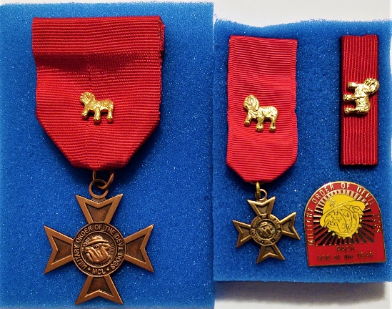**1. 2.**

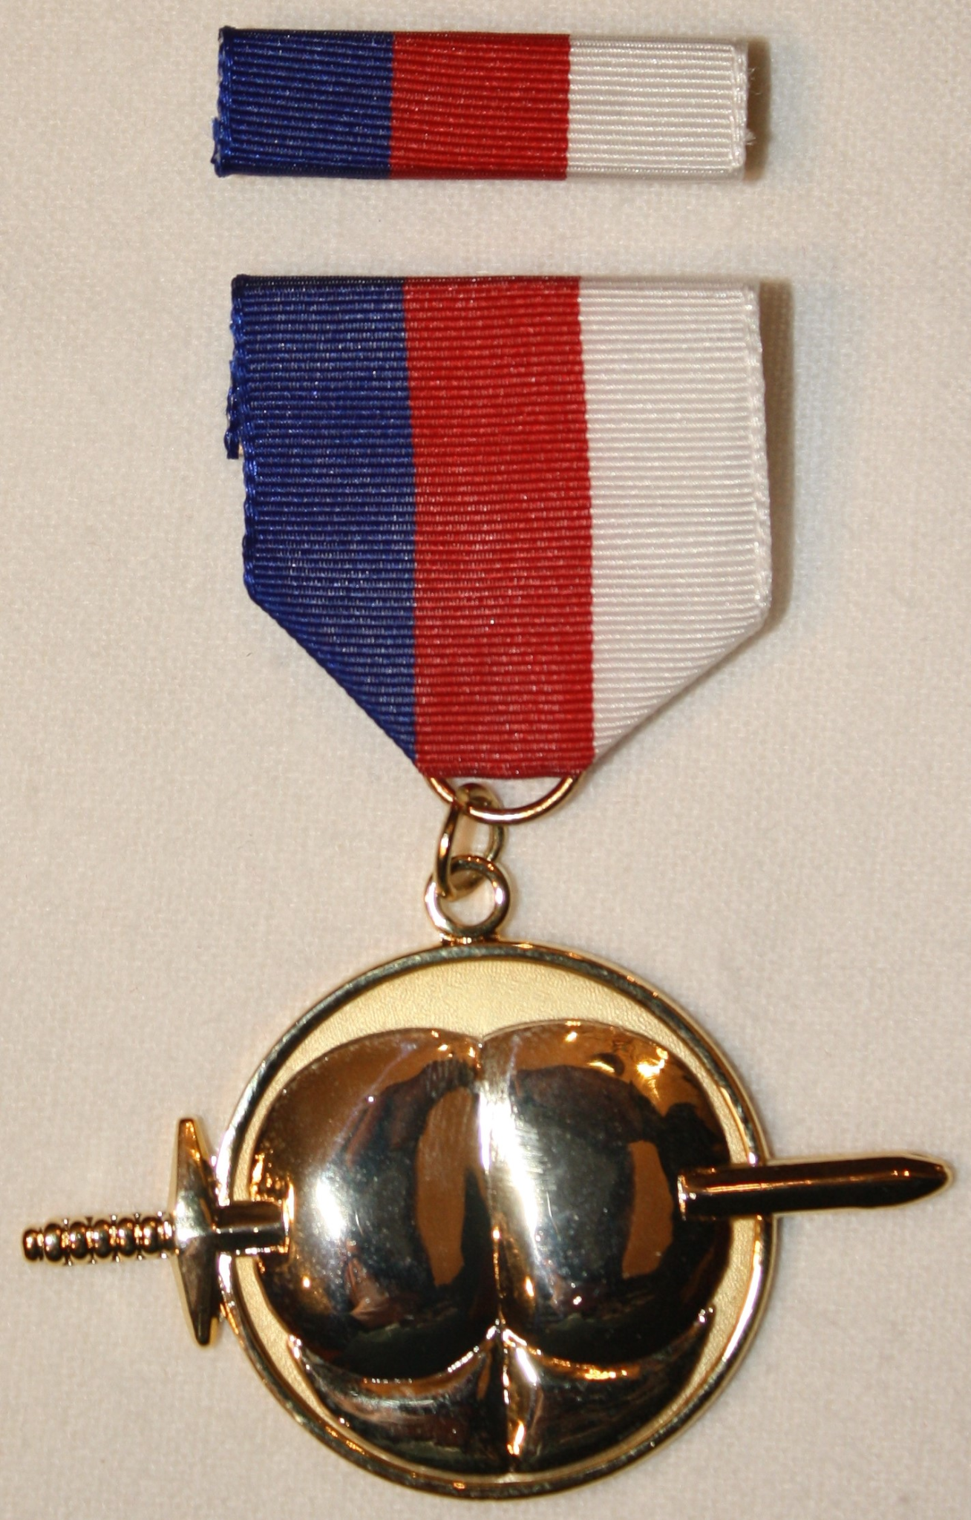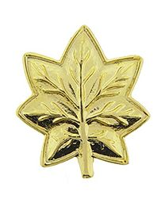

**3. 4.**

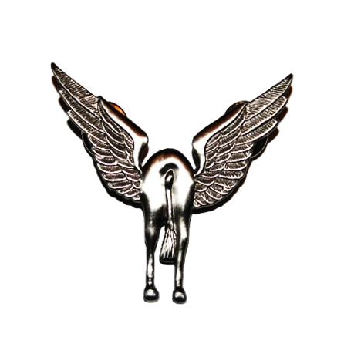

**5. 6.**



**7.** 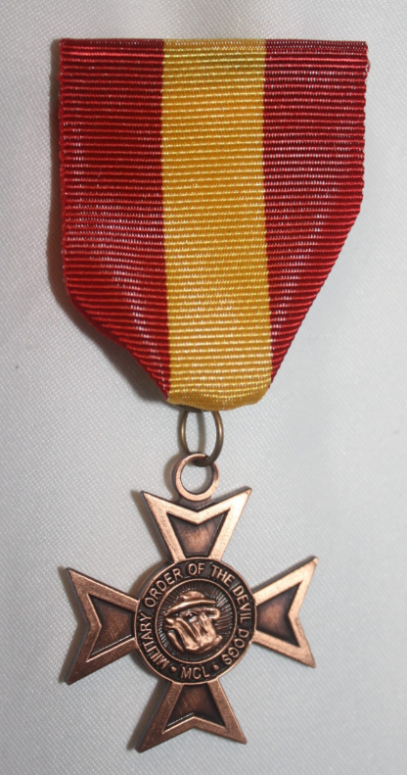

**DEVIL DOG’S CREED**

**By PDD George E. Williams, August 1989**

**(Modified, August 2008)**

I am an American, I was born in France.

I hold the title of United States Marine,

and understand the commitment of holding the title,

**Devil Dog.**

It is a tradition born at Belleau Wood in the year 1918,

of a force in readiness and the “First to Fight.”

As a Devil Dog, I ask no quarter and give no quarter.

I will do everything in my power to uphold the objectives of the Military Order of Devil Dogs

and to carry out my duties to a swift and satisfactory completion.