Military Order of the Devil Dogs

(Name of Pound)

Pound (Pound Number)

Bylaws

(Year Updated or Amended)

**Table of Contents**

**Constitution**

Article I- Preamble ……………………………………………… C-1

Article II- Purpose ……………………………………………… C-1

Article III- Organization ……………………………………………… C-1

Article IV- Membership ……………………………………………… C-2

Article V- Language ……………………………………………… C-2

Article VI- Amendments ……………………………………………… C-2

**Bylaws**

Article I- Membership ……………………………………………… B-1

Article II- Pounds ……………………………………………… B-1

Article III- Fiscal and Financial …………………………………………… B-1

Article IV- Initiation ……………………………………………… B-3

Article V- Uniform ……………………………………………… B-3

Article VI- Installing Officer ……………………………………………… B-3

Article VII- Discipline ……………………………………………… B-3

Article VIII- Policy ……………………………………………… B-3

Article IX- General ……………………………………………… B-3

Article X- Amending of Bylaws …………………………………………… B-3

Pound Bylaw Approvals ……………………………………………… B-5

**Enclosures**

Pound Dog of the Year ……………………………………………… E-1

Pound Keeper’s Meritorious Commendation …………………………… E-2

Certificate of Appreciation ……………………………………………… E-3

Distinguished Service Award ……………………………………………… E-3

Pain in the Ass Award ……………………………………………… E-3

Flying Horse’s Ass Award ……………………………………………… E-4

Past Pound Keeper Medal ……………………………………………… E-4

Devil Dogs Creed ……………………………………………… E-5

**Appendix** ……………………………………………… A-1:A-4

# **Constitution**

# **Article I- Preamble**

We, Marines that hold an honorable discharge from the United States Marine Corps, bona fide, paid up, and active members of the Marine Corps League, Inc., do hereby unite to form a permanent organization to be known as Military Order of the Devil Dogs **(Pound Name)** Pound **(Pound Number)**.

This Military Order of the Devil Dogs **(Pound Name)** Pound **(Pound Number)** of the **(Name of State)** Pack, Military Order of the Devil Dogs, Inc., is hereby created and organized in **(Year)** and chartered on the **(Day of the month)** day of **(Month), (Year).**

The Bylaws of Military Order of the Devil Dogs **(Pound Name)** Pound **(Pound Number)** will never change or remove any Bylaws set forth in the Kennel or Pack Bylaws statute, ever forth.

# **Article II- Purpose**

It shall be the purpose of this organization to:

1. Observe, obey, and support the Bylaws and Administrative Procedures of the MCL.
2. Preserve and strengthen the principles and ideals of the MCL.
3. Aid and assist in the accomplishment of all programs and objectives of the MCL.
4. As the fun and honor society of the MCL, to promote sociability, comradeship, and good fellowship, provide amusement and entertainment at all gatherings of the MCL when and where proper and advisable.
5. Maintain true allegiance to the United States of America and its Constitution and laws; foster and extend American institutions of freedom; and defend America against all enemies.

# **Article III-Organization**

The recognized official bodies of this association shall consist of and be:

1. Local organization to be known as **(Pound Name**) Pound **(Pound Number)** of the MODD, the meeting place of which shall be known as the Pound and the meetings of which shall be known as a Pound Growl.

# **Article IV- Membership**

1. All new members must be voted on by the Military Order of the Devil Dogs **(Pound Name)** Pound **(Pound Number)** membership at a Pound Growl according to Kennel Bylaws statute Article I, Section 101, which must be adhered to.
2. Dues for all Non-Paid Life Members in Military Order of the Devil Dogs **(Pound Name)** Pound **(Pound Number)** shall be $ **(Dues amount)** if paid before the deadline of 31 August of each calendar year.

# **Article V- Language**

Military Order of the Devil Dogs **(Pound Name)** Pound **(Pound Number)** follows all Kennel Bylaws for Article V of the Constitution.

# **Article VI- Amendments**

This Constitution may be amended in the following manner:

1. Devil Dogs within the Military Order of the Devil Dogs **(Pound Name)** Pound **(Pound Number)** or the Pound itself, seeking amendments to this Constitution, shall submit in typewritten form to the Pound Dog Robber, no less than one hundred and twenty (120) days, who will cause the proposed amendments to be published and will provide copies of them to each member. Both acts will occur no less than ninety (90) days prior to the Annual Growl of the Pound at which they are to be considered. The said notice of publication needs only to recite the particular provision of the Bylaw to be amended, revised, or repealed by reference.
2. The Pound Dog Robber will be guided by the instructions in Article XIII of the Kennel Bylaws to ensure that proper notifications have been made promptly.
3. Provisions One and Two of this Article have been complied with, and the proponents and opponents of each proposed amendment shall have no more than five (5) minutes each to state their case. A "standing vote for" and a "standing vote against" shall be taken, and a correct record of the votes "for" and "against" shall be posted in the scratching of the Pound. In each case where it is found that upon a careful count that two-thirds (2/3) of the total registered Devil Dogs have voted "for" a proposed amendment, said proposed amendment shall be considered to be approved, and all members shall be supplied without delay with copies of any amendments approved by the Pound. Proposed amendments that do not receive a two-thirds (2/3) vote of approval shall be void and without effect and shall not be considered nor re-proposed until after the expiration of no less than six (6) months.
4. It shall not be permissible for any session of the Pound Growl to waive any of the foregoing provisions.

# 

# **Bylaws**

# **Article I- Membership**

Military Order of the Devil Dogs **(Pound Name)** Pound **(Pound Number)** follows all of the Kennel Bylaws for Article I. Please refer to Sections 101 through 111 of the Kennel Bylaws for specifics.

# **Article II – Pound**

Military Order of the Devil Dogs **(Pound Name)** Pound **(Pound Number)** follows all of the Kennel Bylaws for Article II.

# **Article III- Fiscal and Financial**

Military Order of the Devil Dogs **(Pound Name)** Pound **(Pound Number)** follows all of the Kennel Bylaws for Article V. Please refer to Section 501 and Section 505 through Section 508 of the Kennel Bylaws for specifics.

Section 502 – Revenue

The revenue of this Order shall be derived from the collection of membership dues, election fees, and other sources that may be approved by the Growl of the Pound or the Pound Staff.

* 1. Limitations: The Pound shall be limited to the spending of not over seventy-five (75%) percent of all monies received during its administration, including monies from the previous administration, and that at least twenty-five (25%) percent of such gross receipts shall be turned over to the new administration each year.
  2. Expenses of Pound Officers: Expenses of the Sir/Madame Pound Keeper and Sir/Madame Pound Dog Robber, whose attendance at the Pound, Pack, and Supreme Growls is not mandatory but advisable, shall be un-reimbursed. This includes but is not limited to all functions and/or transportation. The expenses to be covered will be for postage, copying, and supplies. Payment will be made upon the submission of a detailed expense report.
  3. Administrative Expense: Pound Dogs shall be reimbursed for normal administrative expenses submitted to the Sir/Madame Dog Robber on a voucher and/or detailed expense report subject to the approval of the Pound.

Section 503 – Dues, Amount, and Payment

The amount of the Pound membership dues shall be determined at the annual Growl of the Pound.

Dues for all Non-Paid Life Members in Military Order of the Devil Dogs **(Pound Name)** Pound **(Pound Number)** shall be $ **(Dues amount**) if paid before the deadline of 1 September of each calendar year.

1. Should a check for payment from any member made out to Military Order of the Devil Dogs **(Pound Name)** Pound **(Pound Number)** be returned to the Pound for any reason, the member who issued the check will reimburse the Pound for the total amount of the returned check, returned check fee, and the taxes imposed on such fee.
2. Any increase in membership dues of the Pound shall not be effective until one fiscal year has elapsed following the adoption of the Motion or Resolution increasing said dues.
3. The Pound Dog Robber shall collect the full amount of annual dues of the members of the Order on the roll call of this Pound. The dues shall promptly be submitted to the Worthy Dog Robber by separate remittance.
4. Membership dues are payable in advance and ONLY for the current fiscal year and shall not be prorated. Any new applicant for the Degree of Pup in the Order being initiated after 1 March and prior to 30 June annually will be assessed one-half (1/2) of the annual Kennel and Pack dues for the current year.
5. Membership dues become payable on or before the first (1st) day of September when membership dues become delinquent. If unpaid beyond the last day of the Supreme Growl of the Kennel, the delinquent member shall be dropped from the membership rolls. They may be reinstated as a member in good standing by complying with the provisions of Section 108 of Article I of these Bylaws.
6. Persons not holding a paid-up current Military Order of the Devil Dogs, Inc. and Marine Corps League, Inc. dues card shall be excluded from all Growls of the Order until such time as they have been restored in good standing.

Section 504 – Pound Board of Auditors

The Pound Board of Auditors shall be composed of the immediate three (3) Past Pound Keepers. The senior member shall be the chair.

Should three (3) Past Pound Keepers not be available, the Pound Board of Auditors shall be composed of the three (3) currently elected officers of the Pound who are not account holders on any of the Pound accounts. Until then, the Pound Board of Auditors will be able to be composed. At that time, the senior most elected officer shall be the chair.

# **Article IV – Initiation**

Military Order of the Devil Dogs **(Pound Name)** Pound **(Pound Number)** follows all of the Kennel Bylaws for Article VI.

# **Article V – Uniform**

Military Order of the Devil Dogs **(Pound Name)** Pound **(Pound Number)** follows all of the Kennel Bylaws for Article VII.

# **Article VI – Installing Officers**

The Officer installing the new Officers of a Pound should be a Pedigreed Devil Dog if possible or shall be a Past Pound Keeper, an incumbent Elected Pound Officer or Past Elected Pound Officer or Current/Past Pack Elected Officer or Current/Past Kennel Elected Officer or Division Vice Chief Devil Dog. Immediately following the installation, the Installing Officer shall make a full report to the Worthy Dog Robber, the Honorable Dog Robber, and the Vice Chief Devil Dog of the Division. The report shall include the date and place, names, addresses, and titles of all Officers installed.

# **Article VII – Discipline**

Military Order of the Devil Dogs **(Pound Name)** Pound **(Pound Number)** follows all of the Kennel Bylaws for Article X.

# **Article VIII – Policy**

Military Order of the Devil Dogs **(Pound Name)** Pound **(Pound Number)** follows all of the Kennel Bylaws for Article XI.

# **Article IX – General**

Military Order of the Devil Dogs **(Pound Name)** Pound **(Pound Number)** follows all of the Kennel Bylaws for Article XII.

# **Article X – Amending of Bylaws**

These Bylaws may be amended in the following manner:

1. Devil Dogs within the Military Order of the Devil Dogs **(Pound Name)** Pound **(Pound Number)** or the Pound itself, seeking amendments to these Bylaws, shall submit in typewritten form to the Pound Dog Robber, no less than one hundred and twenty (120) days, who will cause the proposed amendments to be published and will provide copies of them to each member. Both acts will occur no less than ninety (90) days prior to the Annual Growl of the Pound. The said notice of publication needs only to recite the particular provision of the Bylaw to be amended, revised, or repealed by reference.
2. The Pound Dog Robber will be guided by the instructions in Article XIII of the Kennel Bylaws to ensure that proper notifications have been made promptly.
3. Provisions One and Two of this Article having been complied with, the proponents and opponents of each proposed amendment shall have no more than five (5) minutes each to state their case. A "standing vote for" and a "standing vote against" shall be taken, and a correct record of the votes "for" and "against" shall be posted in the scratching of the Pound. In each case where it is found that upon a careful count that two-thirds (2/3) of the total registered Devil Dogs have voted "for" a proposed amendment, said proposed amendment shall be considered to be approved, and all members shall be supplied without delay with copies of any amendments approved by the Pound. Proposed amendments that do not receive a two-thirds (2/3) vote of approval shall be void and without effect and shall not be considered nor re-proposed until after the expiration of no less than six (6) months.
4. It shall not be permissible for any session of the Pound Growl to waive any of the foregoing provisions.

**Pound Bylaws for**

**(Pound Name) Pound (Pound Number)**

**(State) Pack**

# **Pound Bylaws Approval**

The Pound Bylaws were presented to the membership of the **(Pound Name)** Pound **(Pound Number),** Military Order of the Devil Dogs, at the regularly scheduled Growl held in **(City, State),** on the **(Day of the month)** day of **(Month, Year),** and were voted and approved on the **(Day of the month**) day of **(Month, Year).**

**Certification:**

I, PDD **(Name, Dog Tag Number**), Pound Keeper of the **(Pound Name)** Pound **(Pound Number),** Military Order of the Devil Dogs, do hereby certify that the Bylaws were approved by two-thirds (⅔) majority of the membership present.

______________________________________ ________________

PDD **(Name, Dog Tag Number)** Date

Pound Keeper, **(Pound Name**) Pound **(Pound Number)**

**Attest:**

PDD **(Name, Dog Tag Number),** Smart Dog of the **(Pound Name)** Pound **(Pound Number)**, Military Order of the Devil Dogs.

______________________________________ ________________

PDD **(Name, Dog Tag Number)** Date

Smart Dog, **(Pound Name)** Pound **(Pound Number)**

PDD **(Name, Dog Tag Number),** Smart Dog of the **(State)** Pack, Military Order of the Devil Dogs

______________________________________ ________________

PDD **(Name Dog Tag Number)** Date

Smart Dog, **(State)** Pack.

**Enclosures**

# **Pound Dog of the Year (see also Appendix A-1, Image 1):**

Guidelines – Pound Dog of the Year Award:

1. Qualifications and/or Eligibility. A candidate on the Pound Level shall be a member of the MODD and must be in good standing in the Pound. A proposed candidate shall be a Dog of integrity and principles who has contributed to the MODD.
2. Pounds. Each Pound may select a Pound Dog of the Year according to the following.
   1. The Pound Dog of the Year may be a Pedigreed Devil Dog, a Devil Dog, or a Pup.
   2. The Pound Dog of the Year selectee may be submitted to the Pack (if one (1) exists in the state where the Pound is situated) for consideration as Pack Dog of the Year; however, only a Pedigreed Devil Dog or Devil Dog may be submitted to the Pack.
   3. The Pound will submit its nomination for Kennel Dog of the Year directly to the Kennel in accordance with subparagraphs 4-5 of the Kennel Bylaws and will provide a copy of the Nomination to its respective Pack if there is a Pack in that state.
   4. Only a Pedigreed Devil Dog may be nominated for Kennel Dog of the Year. In all cases, ONLY the Pound may make nominations for Kennel Dog of the Year.
   5. Only one (1) nomination per Pound per year is permitted.
3. Pound Dog of the Year Committee
   1. The Pound Dog of the Year Committee will consist of all past recipients of the award who attended the Pound Growl preceding the Annual Growl of the Pound.
   2. The Chair will schedule a said meeting prior to the Annual Growl of the Pound, with reasonable notice given to all eligible members.
   3. The Committee shall have no less than three (3) members.
   4. Each member must be a member in good standing of the MCL and the MODD.
   5. The Pound Dog of the Year Committee will determine the selection process.
4. Submissions:
   1. A Letter of Nomination for the Pound Dog of the Year award must be submitted in the following manner.
      1. Letters of Nominations will only be accepted from a Pound Dog.
      2. Once the Letter of Nomination is submitted, it becomes the exclusive property of the Pound Dog of the Year Committee and may be retained or destroyed at the committee's sole discretion.
      3. Letters of Nomination. Each nomination shall be typewritten, and then placed in a sealed envelope marked, “Candidate – POUND DOG OF THE YEAR Award (current year).”
      4. That envelope shall be placed into a second envelope and sealed, which shall be marked. “Chairperson, POUND DOG OF THE YEAR Committee (current year) c/o the SIR/MADAME DOG ROBBER.”
      5. Delivery of Nomination Letters to Pound- Each Nomination Letter addressed c/o the Sir/Madame Dog Robber at their current mailing address shall be sent by certified mail, return receipt requested in sufficient time to reach the Sir/Madame Dog Robber one (1) month prior to the Annual Growl of the Pound. Nomination letters may be hand-delivered to the Sir/Madame Dog Robber one (1) month before the Annual Growl of the Pound.
      6. All such letters received by the Sir/Madame Dog Robber shall be delivered, unopened, to the Pound Dog of the Year Award Committee Chairperson.
   2. The Society will not accept any nomination that was not submitted and/or received in accordance to the above guidelines:
5. Selection Process:
   1. The Chairperson of the Committee shall ensure that a current copy of the Pound, Pack, and Kennel Bylaws is present during the Committee's deliberations to ensure adherence.
   2. No member of the Committee may reveal to anyone not serving on the Committee the names of the nominees, the discussions held regarding the worthiness or qualifications of the candidates, the ultimate selection, or the criteria by which the nominations were judged.
   3. The method of judging nominations shall be a majority vote of the Committee.
6. Awards:
   1. The presentation to the selectee Pound shall consist of the awards currently available through the Kennel Quartermaster.
   2. Pounds shall purchase their awards from that Officer.
7. Time and Place of Awards:
   1. Pound Dog of the Year shall be presented at the Annual Growl of the Pound.
8. Note in Kennel Bylaws:
   1. For each additional medal or ribbon award, a 5/16” gold star will be worn for each additional award, and a 5/16” Silver Star will be worn in place of five (5) gold stars.

# **Pound Keeper’s Meritorious Commendation (see also Appendix A-1, Image 2):**

1. This award is for exceptionally meritorious service to the Pound.
2. Ribbon: wide Gold center flanked by narrow Blue, White, and Red stripes (outboard to inboard on both sides).
3. It is awarded by Pound Keeper.
4. Wording on certificate through the Quartermaster.
   1. In appreciation and gratitude for the meritorious service in the interests of the United States of America, the United States Marine Corps, the Marine Corps League, and the Military Order of the Devil Dogs.

# **Certificate of Appreciation (see also Appendix A-2, Image 3):**

1. This award is for dedication to the Pound.
2. It is awarded by the Pound Keeper to Dogs of the Pound or anyone else.
3. Wording on Certificate through the Quartermaster.
   1. For dedication and signal distinction to the County, Community and The Military Order of the Devil Dogs for _______.

# **Distinguished Service Award (see also Appendix A-2, Image 4):**

1. This award is for distinguished service to the MODD.
2. This award can also be given to anyone outside of the Military Order of the Devil Dogs who has shown great service to the Military Order of the Devil Dogs.
   1. Wording on Certificate through the Quartermaster.
      1. In appreciation and gratitude for distinguished service in the interests of the United States of America, the United States Marine Corps, the Marine Corps League, and the Military Order of the Devil Dogs, Inc.

# **PIA (Pain in the Azz) (see also Appendix A-3): (NOT WORN ON MCL UNIFORMS)**

1. The PIA Medal and Ribbon.
   1. This is an unofficial “Fun” award that can be used when someone goes above and beyond and is a “Pain in the Azz” for the Pound Keeper.
      1. The Ribbon is Blue, Red, and White.
      2. The Medal is Blue, Red, and White, with a sword going through the buttocks.
         1. Image 5 on Page A-3.
   2. Major PIA.
      1. Gold Oak Leaf pin.
      2. This is for a 2nd PIA award.
         1. Image 6 on Page A-3.
   3. General PIA.
      1. Silver Star.
      2. This is for a 3rd PIA award.
         1. Image 7 on Page A-3.

**The Flying Horse’s Azz Award (see also Appendix A-3): (NOT WORN ON MCL UNIFORMS):**

1. This is a pin of a horse's buttocks with wings.
   1. This is an unofficial “Fun” award that can be used when someone goes above and beyond and is a “Horses Azz” in the eyes of the Pound Keeper.
      1. Image 8 on Page A-3.

# **Past Pound Keeper Medal (see also Appendix A-4):**

1. This is awarded to Pound Keepers upon completion of a term of office.
2. Medal: Bronze cross on ribbon with equal Red, Gold, and Black stripes.
3. Ribbon: Red, Gold, and Black stripes (worn with Red to the wearer’s right).
   1. Image 9 on Page A-4.

# **DEVIL DOG’S CREED**

**By PDD George E. Williams, August 1989**

**(Modified, August 2008)**

I am an American, I was born in France.

I hold the title of United States Marine,

and understand the commitment of holding the title,

**Devil Dog.**

It is a tradition born at Belleau Wood in the year 1918,

of a force in readiness and the “First to Fight.”

As a Devil Dog, I ask no quarter and give no quarter.

I will do everything in my power to uphold the objectives of the Military Order of Devil Dogs

and to carry out my duties to a swift and satisfactory completion.

# **Appendix**

Pound Dog of the Year, with Medal, Ribbon and Lapel Pin (Image 1).

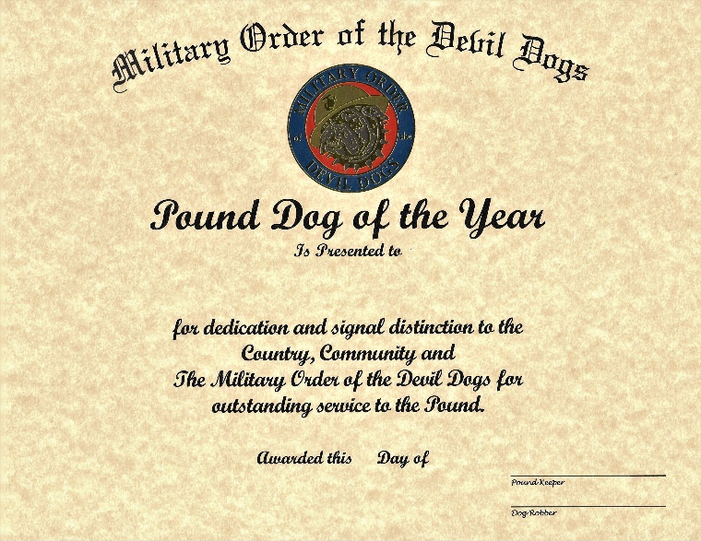

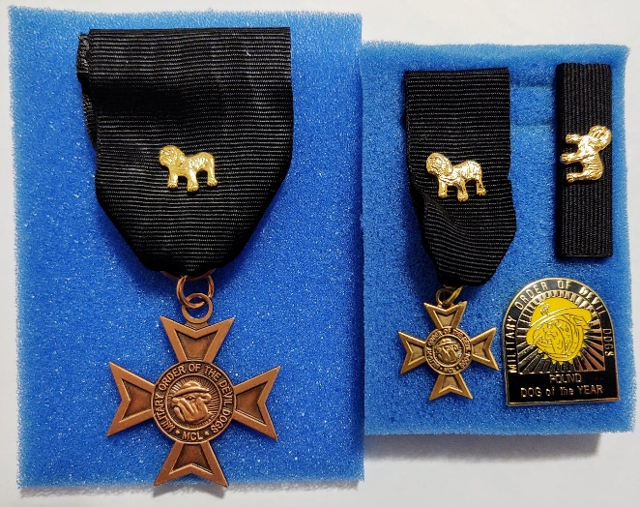

Pound Keeper’s Meritorious Commendation, with Ribbon (Image 2).

Certificate of Appreciation (Image 3).

Distinguished Service Award (Image 4).

Pain In the Azz Awards (Image 5):

PIA Ribbon and Medal, with Major PIA (2nd award) and General PIA (3rd award).

Image 6

Image 7

Image 5

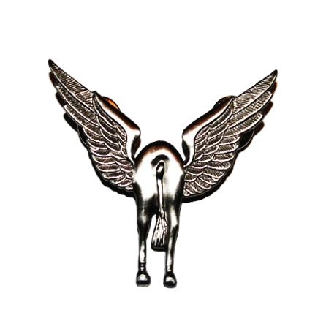

Flying Horse’s Azz Award (Image 8).

Past Pound Keeper Medal and Ribbon (Image 9).

